
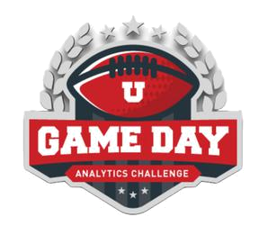
WHITEPAPER

2025 Game Day Analytics Challenge

Team 10

Joonha Park

Linh Do

Syeda Mishra Saiara


TABLE OF CONTENTS
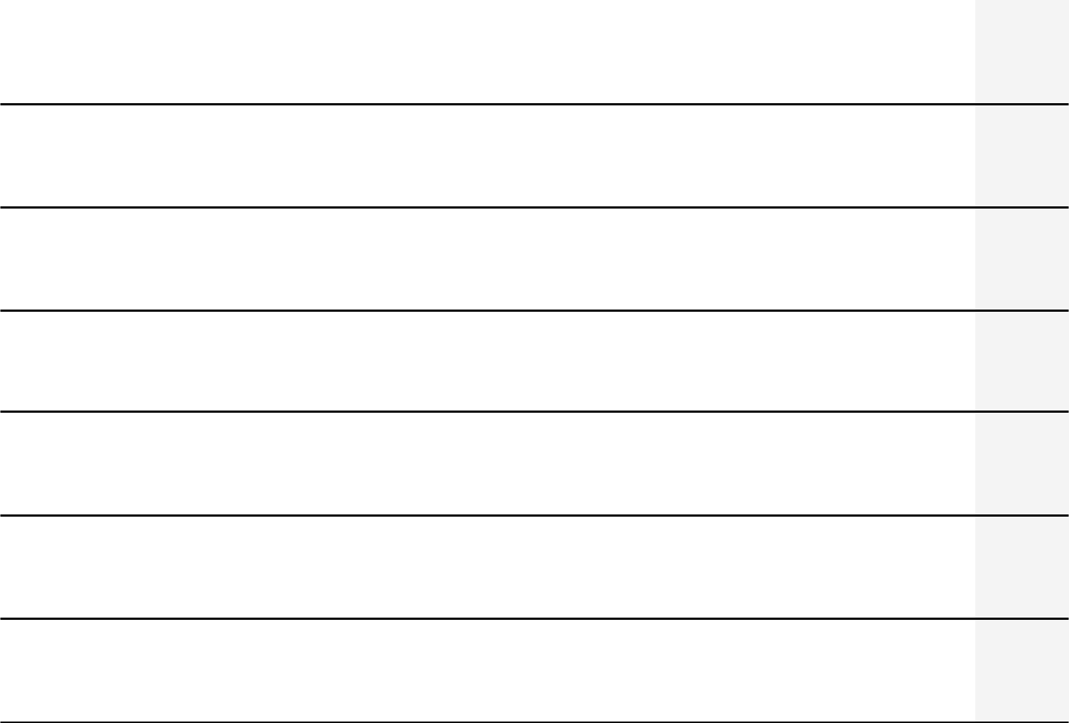

I. Abstract

- Introduction

    - Objective

  - Data Analysis Proceess

- Visualizations and Insights IV. Conclusion
V. Reference

3

4

6

10

11

Team 10 | Page 2

I. ABSTRACT

This white paper offers a thorough examination of Twitter data on commercials that were broadcast at Super Bowl LIX in 2025, emphasizing the financial impact, celebrity influence, and brand sentiment. We analyze about 60,000 tweets to find important trends and offer practical suggestions for companies looking to maximize their advertising budgets.

The dataset was cleaned and structured using Python libraries such as pandas and regex, while sentiment analysis was conducted with NLTK and TextBlob. Engagement metrics were correlated with estimated advertising costs to evaluate cost-effectiveness, and Tableau dashboards were used to visualize tweet activity, geographic distribution, and engagement patterns. Additionally, stock price fluctuations were analyzed from outside data sources to assess the financial impact of brand mentions.

Key insights reveal that commercials featuring NFL players generated the most positive sentiment, while brands such as TurboTax, despite high mention volumes, experienced elevated costs per engagement. Peak Twitter activity occurred during the fourth quarter and immediately after the game, highlighting optimal times for social media engagement. Additionally, we also found interesting insights mentioned in detail in later parts.

Our analysis provides practical guidance for brands aiming to refine their messaging, enhance engagement, and maximize ROI in future Super Bowl advertising campaigns.

BACKGROUND

The Super Bowl stands out as one of the most important sporting occasions in United States because millions of people watch each year for both the football match and the much-awaited halftime shows and commercials that have developed into a significant cultural event. Super Bowl commercials function as essential marketing instruments because companies allocate extensive resources to develop creative campaigns which emotionally connect with viewers while building brand awareness and enhancing consumer interactions. These advertisements achieve strategic brand-building results through their ability to shape public perception and influence consumer behavior because they reach massive audiences and receive extensive media coverage. Super Bowl advertising's competitive environment forces brands to create distinctive and powerful messages that connect with various audiences which helps to build market strength and ensures marketing longevity.

Team 10 | Page 3

- INTRODUCTION

  - OBJECTIVE

We analyze Twitter data on the 2025 Super Bowl LIX Commercials in order to extract valuable insights and provide actionable recommendations for brands. In particular, we look into the effectiveness of commercials through brand sentiment analysis, celebrity influence, and stock price impact.

From our findings, brands can optimize their advertising strategy by refining advertising messages, selecting effective endorsers, and assessing financial impact to maximize ROI. In addition, brands not participating in Super Bowl commercials can still leverage our insights by analyzing competitor performance, identifying effective messaging trends, and assessing audience sentiment

2. DATA ANALYSIS PROCESS

2.1. TOOLS AND TECHNOLOGIES USED

Python (pandas, NLTK, TextBlob, regex) – Data preprocessing, sentiment analysis, keyword extraction, and text cleaning.
Google Colab – Cloud-based coding environment for data analysis and visualization.

Tableau – Data visualization and dashboard creation.

2.2. DATA CLEAN UP

The dataset was retrieved from Google Drive and initially explored using pandas to understand its structure.
Duplicate tweets were removed, and missing data was addressed.

Key elements such as hashtags, mentions, and emojis were extracted from tweet texts using regex.
Location data was standardized by categorizing it into "City," "State," and "Country."

Language abbreviations were converted into full names to enhance readability. Text normalization techniques were applied, including lowercasing, removal of special characters, and filtering of stopwords.
The final structured dataset was stored in Google Colab for further visualization and analysis in Tableau.

Team 10 | Page 4

2.3. DATA ANALYSIS METHODOLOGY

Cost per Engagement:

The effectiveness of advertisements was estimated by correlating brand engagement with estimated ad spending impact.
Brand Sentiment Analysis:

Tweets were categorized into positive, neutral, or negative sentiment using NLTK and TextBlob.
Celebrity Mentioned Score:

The mentioned score is determined based on number of hashtags on tweets.

Top 10 Tweeted brands & Top 10 Tweeted Hashtags:

The frequency of ad mentions and hashtags was calculated using pandas.

The results were visualized in Tableau dashboards.

Tweet Activity Over Time & Quarter Analysis:

Tweet activity was analyzed across different game quarters using Tableau to identify engagement patterns.
Stock Price Changes:

Brand mentions were analyzed in correlation with stock price fluctuations to assess the financial impact of advertisements.
Proportion of Sensitive Content:

Audience reactions to sensitive ad content were evaluated using NLP techniques.
Controversial topics were detected, and engagement levels were measured.

States of Tweets:

The geographic distribution of tweets across U.S. states was visualized in Tableau.

Team 10 | Page 5

  - VISUALIZATION AND INSIGHTS

- TOP 5 BRANDS BY COST PER ENGAGEMENT
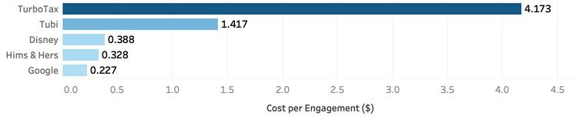

In 2025 Super Bowl LIX, brands paid $8M per 30-second commercial between game quarters. In this analysis, we calculate the Return on Investment by evaluating the cost per commercial against the total number of engagements. This metric helps brand review their investment in Super Bowl commercials.

TurboTax with "Now Taxes is So Sweet" commercial featuring Issa Rae obviously has the greatest cost per engagement ($4), leading by a significant margin.

2. TOP 5 BRANDS BY SENTIMENT ANALYSIS
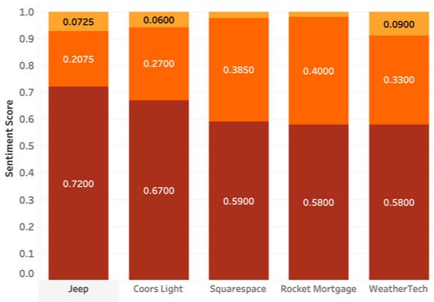

This analysis evaluates sentiment distribution— positive, neutral, and negative—across the top five brands based on audience reactions. Sentiment analysis provides key insights into how well each brand’s message resonated with viewers.

Jeep with “There’s Only One” featuring Harrison Ford leads with the highest positive sentiment (72%).

3. TOP 5 MENTIONED CELEBRITIES
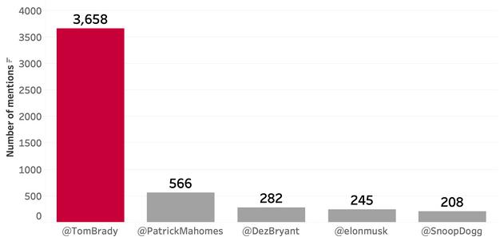

Our celebrity analysis aims to see the influence of celebrities in the commercials.

Tom Brady dominated discussions with 3,658 mentions, significantly outpacing all others — likely because he is a NFL player and participated in 2 commercials: Duracell & No Reason to Hate. Interestingly, all top 3 celebrities are all NFL players.

Team 10 | Page 6

4. TOP 10 TWEETED BRANDS
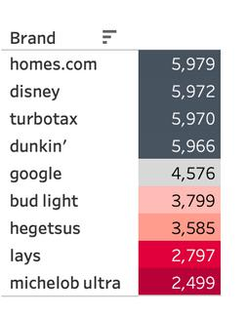

This chart highlights the most mentioned brands on Twitter. "home.com (5,379 tweets)," "Disney (5,372 tweets)," and "Starbucks (5,370 tweets)" had the highest engagement, indicating their commercials were among the most impactful. Notably, Michelob Ultra (2,489 tweets) had the lowest mentions among the top 10. This suggests that brands with highly engaging or emotionally resonant commercials generated more online discussions.

5. MOST TWEETED HASHTAGS #
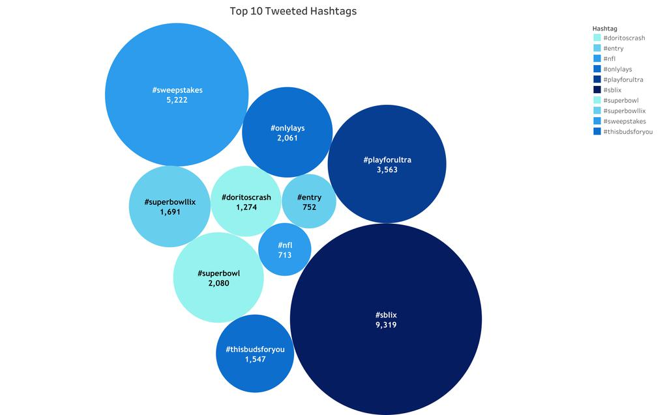

This chart represents the top 10 most tweeted hashtags related to the Super Bowl. The most mentioned hashtag, #sblix (9,319 tweets), refers to "Super Bowl LIX," the 59th edition of the event. Other popular hashtags include #sweepstakes (5,222 tweets), which is related to promotional giveaways, and #playforultra (3,563 tweets), likely a campaign by Michelob Ultra.

Team 10 | Page 7

6. TWEET ACTIVITY OVER TIME/QUARTER
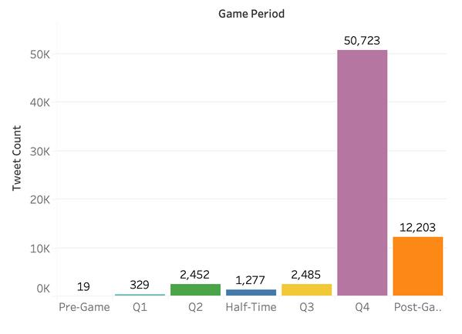

This chart illustrates tweet activity across different game periods during the Super Bowl. The highest engagement occurred in the 4th quarter (50,723 tweets), indicating a peak in excitement or controversy. Post-game discussions were also significant (12,203 tweets), while pre-game activity remained minimal (19 tweets), suggesting that most conversations happened during or after the game.

7. STOCK PRICE CHANGES
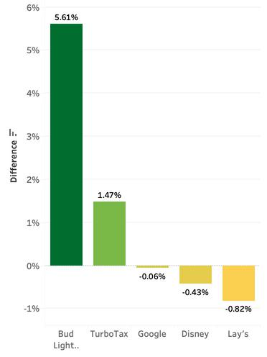

As expected like every year, the stock price changed for brands after the superbowl commercials release. While some increased very significantly, few others had a visible loss in stocks too. We extracted the stock price data from websites, keeping the date range from Feb 7, 2025 (closing date before the Superbowl) till Feb 14, 2025 (closing date after the Superbowl). There was a significant rise in the stock price of Bud Light/Michelob Ultra, with an increase of 5.61% within this duration. The rise of stock prices to 1.47% for TurboTax is aligned with their highest spending in promoting and engagement. Meanwhile, being one of the most mentioned brands, there was a stock downfall of 0.43% for Disney. But the highest decrease in price was observed for the brand Lay’s owned by PepsiCo with a difference of

.82%

Team 10 | Page 8

8. PROPORTION OF SENSITIVE CONTENT
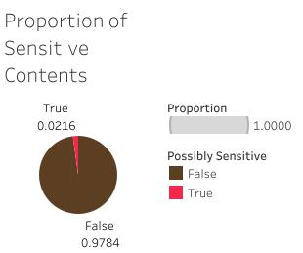

The pie chart highlights a possible sensitivity among the tweets in the dataset this year. It indicates that while almost 98% of the tweets were considered to be in the positive range, there were 2% amongst them which could be sensitive to any community or groups or people. To determine this sensitivity range, we kept a range score for the tweets analyzed and considered them neutral or positive and negative accordingly.

9. NUMBER OF TWEETS PER STATE
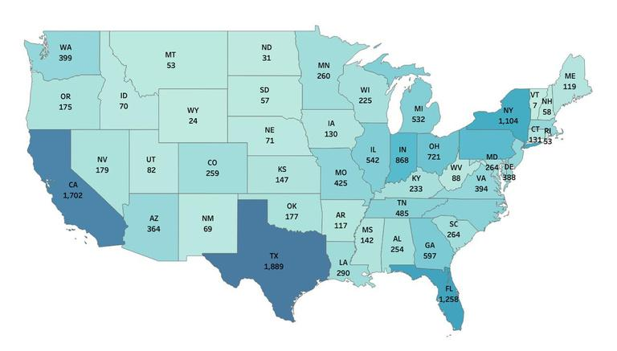

After extraction and analysis from the location of the tweets, it was found some insights that are depicted in the numerical graph above. The highest number of tweets were found to be from Texas (1,889), California (1,702) , Florida (1,258), and New York (1,104). There were significantly fewer tweets from the states of Wyoming (24), Vermont (7), and North Dakota (31). It could be said that the states of Illinois (542),

Michigan (532), and Georgia (597) had moderate engagement during Superbowl this year.

Team 10 | Page 9

IV. CONCLUSION

Based on the analysis above, some key recommendations can be made for brands to optimize their marketing strategies.

Commercials featuring NFL players are most well-received by audience. Brands should consider collaborating with these stars in future campaigns to maximize impact.
Even though TurboTax is one of the most tweeted brands, it also has greatest cost per engagement. Brands should evaluate the cost-effectiveness of their campaigns and explore ways to enhance engagement while managing costs.
Since most tweets happened during the 4th quarter (50,723 tweets) and after the game (12,203 tweets), brands should plan their ads and social media posts around these times to maximize engagement.
As Texas, California and Florida demonstrate strong audience engagement, brands should consider targeting their marketing campaigns to these key demographics.

However, it is important to acknowledge the limitations of our analysis. Tweets only represent a subset of the Super Bowl audience and may not fully capture the opinions of groups such as the elderly, who are less likely to use social media. Moreover, stock price fluctuations may be influenced by various micro and macroeconomic factors that go beyond the scope of this analysis.

Team 10 | Page 10

V. REFERENCES

Yahoo Finance. (n.d.). Yahoo Finance. Retrieved February 2025, from

https://finance.yahoo.com/

Google Finance. (n.d.). Google Finance. Retrieved February 2025, from

https://www.google.com/finance/

Statista. (2025). Super Bowl 30-second ad costs. Retrieved February

2025, from https://www.statista.com/statistics/217134/total-advertisement-revenue-of-super-bowls/

Team 10 | Page 11

